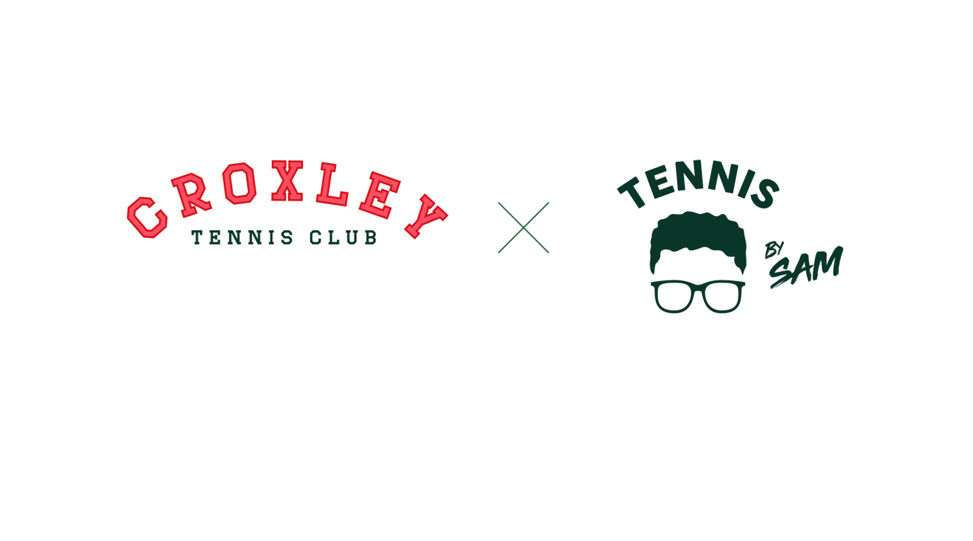

**Junior Coaching Direct Debit Policy**

Membership is required for participation in the **Junior Programme at Croxley Tennis Club**, but not for school sessions or holiday camps. For membership details, visit [Croxley Tennis Club Membership](https://clubspark.lta.org.uk/CroxleyTennisClub/Membership/Join).

Payments for the Junior Programme are processed on the **17th of April**, **17th of August**, and **17th of December**, with direct debits every 4 months thereafter. **At least one month's notice** is required for cancellations.

**Performance Programme (Croxley Crocodiles)**: If you're part of the Croxley Crocodiles, your performance session is free. However, you are required to sign up for at least one **Otters group session** each week.

**Session Pricing**:

* 60 minutes: £8.50
* 75 minutes: £10.00
* 90 minutes: £12.50
* 120 minutes: £14.00

**Cancellations & Refunds**:  
If a session is cancelled, you will receive a deduction on your next direct debit. Refunds will only be provided in special circumstances.

For more information, please contact Sam Ranger at:  
**Email**: sam@tennisbysam.com  
**Phone**: 07850 100016